
Faculty of Business and Technology: Programme – MSc Applied Data Science
NAME: Singo Loua
STUDENT NUMBER: 240086608
MODULE CODE: PROM 02
MODULE TITLE: Computing Master’s Project
MODULE LEADER: Dr. Thomas Thu Yein
SUBMISSION DATE AND TIME: 23/02/2026 at 11:00
ASSIGNMENT: Planning Review
Academic Misconduct is an offence under university regulations, and this involves:
- Plagiarism – where you use information from another information source (including your previously submitted work) and pass it off as your own. This can be through direct copying, poor paraphrasing and/or absence of citations.
- Collusion – where you work too closely, intentionally, or unintentionally, with others to produce work that is similar in nature. This can be through loaning of materials, drafts or through unauthorised use of a fellow student’s work.
- Asking another person to write your assignment – where you ask another individual or company to complete your work for you, be that paid or unpaid, and submit it as if it were your own.
- Unauthorised use of artificial intelligence – where you use artificial intelligence tools to generate your assignment instead of completing it yourself and/or where you have not been given permission to use artificial intelligence tools by your module leader. Please complete the following declaration around you use of artificial intelligence tools in your assignment.

STATEMENT ON USE OF ARTIFICIAL INTELLIGENCE TOOLS:
- I have used artificial intelligence tools to generate an idea for my assignment: NO
- I have used artificial intelligence tools to write my assignment for me: NO
- I have used artificial intelligence tools to brainstorm ideas for my assignment: NO
- I have used artificial intelligence tools to correct my original assignment: NO

DECLARATION
- I understand that by submitting this piece of work I am declaring it to be my own work and in compliance with the university regulations on Academic Integrity.
- I confirm that I have done this work myself without external support or inappropriate use of resources.
- I understand that I am only permitted to use artificial intelligence tools in line with guidance provided by my Module Leader, and I have not used artificial intelligence tools outside this remit.
- I confirm that this piece of work has not been submitted for any other assignment at this or another institution prior to this point in time.
- I can confirm that all sources of information, including quotations, have been acknowledged by citing the source in the text, along with producing a full list of the sources used at the end of the assignment.
- I understand that academic misconduct is an offence and can result in formal disciplinary proceedings.
- I understand that by submitting this assignment, I declare myself fit to be able to complete the assignment and I accept the outcome of the assessment as valid and appropriate.

ANY OTHER COMMENTS FROM STUDENT:



Faculty of Business &Technology

School of Computer Science & Engineering

PLANNING REVIEW
PROM02
MSc Dissertation
Academic Year: 2025/26

Student Name: Singo Loua
Student ID 240086608
Email: bi76tf@student.sunderland.ac.uk
Programme: MSc Applied Data Science
Mode: Full Time

Supervisor: Dr. Ming Jiang

Terms of Reference

Project Title

Deep Learning and Visual Language Model (VLM) based Real-Time Fighting Detection on Beach Safety Management

Project Overview

Aim:
Developing and evaluating a system for detecting beach fights in real time is the project’s main goal using both YOLOv8 and an AI agent using Visual Language Models (VLM). This will include a pipeline for rendering thermal silhouettes of people on the beach to protect their privacy and a ChatBot in Natural Language that security personnel will use to ask questions about—and view in real time—people on the beach from the camera.

Objectives:
- Complete a synthesis of ten scholarly journal articles from 2020 through 2026 regarding (1) fight detection (2) vision-language models, e.g., LLaVA, CLIP (3) artificial intelligence agents used in surveillance, (4) thermal-based rendering of private information, and (5) safety systems for beach use. The synthesis will provide an annotated bibliography of the research gaps related to these areas.
- Start collecting 600 to 1,000 video clips of fighting incidents at beaches/parks from the UCF-Crime and RWF-2000 datasets. Once these video clips are collected, use the thermal silhouette rendering pipeline to anonymize all individuals from each of the video clips. Create an annotated data set with 70% training, 15% validation, and 15% testing splits.
- Utilize a YOLOv8 model to train for physical assault detection that is adopted to work in conjunction with a Vision-Language Model (VLM), such as LLaVA or CLIP, for allowing scene-level reasoning. The final model should achieve a minimum mAP at a threshold of 0.5 = 0.75 and demonstrate the ability to perform inference at 25 frames per second (FPS) or faster, when evaluated on 720p beach surveillance video.
- Evaluate the entire model system using the test data set on the beach, employing metrics including Precision, Recall, F1-score, mAP at 0.5, FPS, false positive rate, and accuracy of VLM output. The evaluation will include a comparison of the results to at least one published baseline in the academic literature
- Use the AIF360 or Fairlearn framework to perform an audit of fairness and bias on the demographic groups and beach lighting conditions, then validate that the thermal silhouette rendering meets the requirements of the UK GDPR Article 5 data minimization principles by effectively anonymizing identifiable features.
- Develop and demonstrate a working prototype of beach safety that integrates the YOLOv8, VLM AI agent, thermal silhouette renderer, and natural language chatbot in a Gradio/Streamlit dashboard to enable live operator tracking queries with real-time responses powered by the VLM.

Research Question:
Can a VLM AI system detect fighting in beach surveillance videos accurately in real-time while maintaining individual privacy through thermal silhouette rendering, allowing users to query using natural language, and achieving quick inference speed with minimal false positives?

Practical outcomes:

- A dataset of videos showing physical altercations at beaches (a subset of UCF-Crime, as well as RWF-2000) which have been processed using an RGB-to-thermal conversion method involving a "warm shape" rendering pipeline that processes raw surveillance footage from cameras into anonymised body silhouettes with pose data retained to detect actions, and the three datasets are split into training / validation / testing 70% / 15% / 15%.
- A YOLOv8 model with an in-built VLM reasoning agent can be successfully generated based upon pre-trained data sets. The results from this model have been measured for mAP@0.5, and the frame rate has also been established, using training scripts that will be submitted for each new project to maintain manual backup copies, making all of the data available for validation.
- A comprehensive assessment report showcasing detection metrics, VLM reasoning accuracy, and resolution rates for the chatbot; with annotated frame-level examples of the errors and candid analysis of cause(s).
- An ethics report for the purpose of documenting fairness audit findings across multiple groups and lighting conditions; confirming that thermal renders comply with GDPR, addressing the rate at which VLM has issued hallucinations and documenting the steps taken to prevent abuse by the chatbot.
- A functioning prototype that incorporates all functions into one dashboard: thermal silhouette overlays, detection boxes and automatic alerts alongside a chatbot window allowing an operator to enter queries such as"track the person in the blue cap" and receive a live response from the system.

Underpinning research with Literature Review

The table below shows the 10 papers I have reviewed so far. I have chosen these papers intentionally because they represent both the technical and ethical aspects that are important to my study. I have also indicated how I will use each paper in relation to my research question, as well as how I will specifically develop the elements of each paper that relate to my study.

Citation | Brief summary of paper | Relevance to my research question | Relevance to practical outcome of project
- Qi, B., Wu, B. & Sun, B. (2025). Automated violence monitoring system for real-time fistfight detection using deep learning-based temporal action localisation. Scientific Reports, 15(1), 29497. | - Proposes MSTFDet combining RGB and skeletal data via CAET transformer and ST-GCN networks.  - Achieves 92.3% MCA on SCFD and 95.2% MCA on RWF-2000 dataset.  - Demonstrates that multimodal temporal fusion outperforms CNN-only approaches significantly.  - Identifies motion blur and occlusion as primary failure modes in crowded environments. | The use of temporal multimodal fusion is more effective than using a single-frame YOLO for detecting fights, thus allowing for the inclusion of the VLM AI agent layer in this project. Due to the ambiguity of visual cues generated during beach activities, it has been demonstrated that single-frame detection cannot resolve these ambiguities. Therefore, contextual scene reasoning is required (92–95% MCA) and shows that YOLO by itself is not sufficient without temporal modelling. | The accuracy benchmarks used for evaluation (D15) are 92-95% MCA; the RGB-skeletal multimodal approach will affect the design of the thermal silhouette rendering by utilizing YOLOv8 pose estimation keypoints to create anonymized body shape overlays while retaining the appropriate fighting poses but eliminating identifying characteristics.
- Fatima, K. & Ahmed, M. R. (2025). Real-time crowd crime and violence detection using deep learning-based face recognition and object detection. International Journal of Scientific Research in Engineering & Technology, 5(4), 20–23. | - YOLOv8 achieves 93% detection accuracy and 25 ms per frame at 30–40 FPS on CCTV footage.  - Integrates CNN-based face recognition for perpetrator identification in crowded scenes.  - Streamlit dashboard delivers sound and email alerts within two seconds of detection.  - Validated on metro stations, stadiums and airports in real-world conditions. | In this study, the authors demonstrated that a 25 frames per second (FPS) frame rate can be achieved using the YOLOv8 in real-world environments with large crowds of people present. In addition, the Streamlit Dashboard's email alerts and sounds will act as good reference points for designing my operator interface prototype. | The Streamlit Dashboard provided 93% accuracy at more than 30 FPS, and this will serve as a baseline for my evaluation. The indoor/urban test environment demonstrated the impact of adapting the beach domain to multiple environments including changes in lighting, waves, and distance to the subject from the CCTV location. The Streamlit Dashboard also informed my design of the operator interface for the chatbot.
- Verma, A. (2025) ‘Real-time violence detection in surveillance streams’, SSRN Preprint. Available at: https://papers.ssrn.com/sol3/papers.cfm?abstract_id=5326645 [Accessed: 21 February 2026]. | - Fine-tunes DenseNet121 on 1,000 labelled UCF-Crime frames for binary violence classification.  - Achieves 92% validation accuracy and 0.91 weighted F1-score using class balancing.  - Implements multithreaded RTSP stream processing at 30 FPS on a T4 GPU.  - Integrates Flask dashboard, MongoDB logging and Dropbox cloud storage for deployment. | Validating UCF-Crime as the most appropriate primary dataset for this study shows evidence of indoor/CCTV biases and this study will address that gap. This validation illustrates the need to supplement UCF-Crime with RWF-2000 and how the thermal rendering pipeline will be used in conjunction with the beach surveillance data. | The multithreaded inference architecture (30 FPS on T4 GPU) will provide an indication of how well the beach surveillance pipeline (D18) will run in real-time, since detections, virtual long model reasoning, and chatbot responses must all be processed at ≥25 FPS at the same time. It validates UCF-Crime for D10 and finds a gap in datasets related to beach-context datasets, thus supporting the use of RWF-2000 to supplement UCF-Crime as the primary dataset.
- Ojha, R. R., Chawdary, H. & Saraswat, S. (2025). Enhancing public safety: real-time violence detection and notification system. Procedia Computer Science, 258, 2988–2995. | - Combines Faster R-CNN and lightweight MobileNetV2 for real-time violence detection.  - Integrates Telegram bot for instant alert delivery to security personnel.  - Outperforms existing models on balanced and unbalanced datasets.  - • Demonstrates reduced false positive rates compared to CNN-only baselines. | The beach safety research project emphasizes reducing false positives. Using Faster R-CNN with MobileNetV2 allows for decreased false positives when utilizing unbalanced datasets. The integration of a Telegram alert system helps notify users about incidents in real-time. | The use of MobileNetV2 as a backbone supports the design of an AI agent that will perform with low latency on hardware at the beach; this would allow for the possible deployment of the AI agent at lifeguard stations that have limited computing capability when comparing to CCTV servers inside buildings.
- Evany Anne, M. & Sivakumaran, N. (2025). An intelligent crime surveillance video system for real-time applications. Procedia Computer Science, 260, 635–644. | - Integrates YOLO for detection, DeepSort for tracking and OpenPose for skeletal pose estimation.  - Uses LSTM networks to classify violent actions from OpenPose keypoint sequences.  - Stores incident images to Firebase with timestamps upon violence detection.  - Demonstrates lightweight pipeline across diverse indoor and outdoor environments. | Deepsort tracking for multi-person tracking through natural language chat bots enables the ability to make queries (e.g., tracking the person in red shorts) by maintaining a persistent unique subject identifier for each subject across beach camera feeds. Allows for real-time viability of tracking for beach safety system with multiple people present. | Provides an architecture for combining detection, tracking, and chat bots. Uses keypoints from openpose to create a thermal silhouette, thus not requiring a separate image segmentation model to render anonymized body shape overlays and improving efficiency. The firebase style reporting of incidents will sync to project's alert system.
- Solak, S., Cetin, B. & Ucar, M. H. B. (2025). Real-time theft detection in urban surveillance: a comparative analysis of YOLO-based approach. Journal of Engineering Research. | - Compares YOLOv4, v5 and v8 for theft anomaly detection on a 3,133-image custom dataset.  - YOLOv8 achieves 98–99% detection accuracy for snatching-relevant anomalies.  - Django web interface provides email alerts, admin dashboard and SQLite incident logging.  - Identifies low lighting and partial occlusion as key challenges for theft detection. | There is a quantitative justification using comparative analysis of YOLOv4, YOLOv5, and YOLOv8 to support using YOLOv8 to be the backbone for detection and that YOLOv8 achieved 98%-99% detection accuracy. The web-based alert interface will inform the operator chatbot dashboard design in the beach safety prototype. The quantitative analysis provided by using the O generations is also a justification for making YOLOv8 the primary architecture. | YOLOv8 has been shown to be the most effective object detection backbone. The complexity of the beach background (waves/varied illumination conditions) exposes a significant difference between domain-specific fine-tuning and the target of this project (thermal rendering). The multi-modal alerting pipeline (email/web interface/logging) serves as a template for the Beach Safety Notification System.
- Sultani, W., Chen, C. & Shah, M. (2018). Real-world anomaly detection in surveillance videos. Proceedings of IEEE CVPR, pp. 6479–6488. | - Introduces the UCF-Crime dataset: 1,900 surveillance videos across 13 anomaly classes.  - Proposes a weakly-supervised ranking loss for anomaly detection without frame-level labels.  - Achieves AUC of 75.41% on the UCF-Crime benchmark using a deep MIL ranking model.  - Establishes UCF-Crime as the primary benchmark dataset for surveillance anomaly detection. | The basic dataset for this study; UCF-Crime, is also a highly relevant dataset to be used with the goal of creating an applicable class for the purpose of creating a functional class for legal fighting. Additionally, both Indoor & CCTV bias would provide the basis for using RWF-2000 to develop the dataset and then develop a visual representation of it. Evaluation of a weakly-supervised ranking loss as a method for training the VLM AI Agent, is conducted. | This study will use the primary dataset, and provide the anomaly detection baseline for this dataset. The benchmark for comparative evaluation will be the AUC of 75.41%, therefore this will serve as the baseline for future testing. Evaluation of weakly-supervised ranking loss as a contextual training method for the VLM AI Agent will also be conducted.
- Jocher, G., Chaurasia, A. & Qiu, J. (2023). Ultralytics YOLOv8 [Software]. Version 8.0.0. GitHub. | - YOLOv8 introduces anchor-free detection with improved backbone (C2f) and neck architecture.  - Supports multi-task learning including detection, segmentation, classification and pose estimation.  - Achieves state-of-the-art mAP on COCO benchmark while maintaining real-time inference speed.  - Provides a Python API and pre-trained weights for efficient fine-tuning on custom datasets. | Establishes the primary detection framework. Integrated through anchor-free designs and Python APIs will allow for fine-tuning of the thermal-rendered beach dataset. Multi-task support (both detection and pose estimation) will allow for the incorporation of the VLM AI agent for scene context-based judgments for the overall beach safety system. | Establishes the primary detection framework. With pre-trained COCO weights, transfer learning on the beach thermal dataset can occur. Also, Pose estimation using YOLOv8 can provide skeletal keypoint extraction from the pipeline of thermal silhouettes, allowing for the anonymization of people at the beach.
- Tran, D., Bourdev, L., Fergus, R., Torresani, L. & Paluri, M. (2015). Learning spatiotemporal features with 3D convolutional networks. Proceedings of IEEE ICCV, pp. 4489–4497. | - Proposes C3D, a 3D CNN architecture for learning spatiotemporal features from video clips.  - Outperforms 2D CNN baselines on action recognition benchmarks including UCF-101.  - Demonstrates that 3×3×3 convolution kernels optimally capture spatiotemporal information.  - Establishes foundation for temporal action recognition in surveillance video analysis. | Theoretical foundation for temporal reasoning implemented in the VLM AI agent. Spatiotemporal properties differ in the execution of beach fighting versus recreational uses (e.g., swimming, rough play), despite there being similar movement patterns; they differ substantially with respect to temporal order and the spatial context where they occur. | Impacts the temporal extension model in that C3D spatiotemporal features, evaluated as an additional type of contextual input for the VLM AI agent, enable scene-based reasoning that allows the distinguishing of beach fighting from recreational activities such as water play (i.e., splashing) contact sporting events, and rough play.
- Redmon, J. & Farhadi, A. (2018). YOLOv3: An incremental improvement. arXiv preprint arXiv:1804.02767. | - Introduces multi-scale detection using three different scales with feature pyramid approach.  - Uses Darknet-53 backbone achieving 51.5% AP on COCO at 20 ms inference time.  - Demonstrates real-time object detection on constrained hardware at competitive accuracy.  - Provides foundational YOLO architecture upon which YOLOv8 iteratively improves. | Establishes the basis for the YOLO approach to YOLOv8; the multi-scale feature pyramid is essential for monitoring the beach, where cameras can pick up items at widely differing distances - such as close to the front of the camera versus far away at the waterline. | The YOLO architectural lineage sets the stage for designing systems around it. The transition of YOLO versions from 3 to 8, gives context to the ≥25 FPS benchmark of beach thermal video, and strongly supports the use of anchor-free YOLOv8 to detect fighting subjects at multiple scales within coastal video. This also gives older baselines for comparative assessment of previous versions, and illustrates continued forward progress from previous versions of the architecture, as submitted in the analysis report.

Project Schedule

The project will run for 16 weeks, starting on January 16th , 2026, with a target completion date of May 11, 2026. As of February 20th , an evaluation of the project with my supervisor resulted in a change of scope (including a new title) that identifies VLM as a method of beach safety management. The Planning Review was delivered to the committee on February 23nd , with Phases 2 through 7 also to include the literature review and the establishment of a thermal silhouette data set, YOLOv8 + VLM AI agent, web-based ChatBot, evaluative assessment and submission of the dissertation by May 8th , 2026, in time for the Viva Voce on May 11th , 2026.

Table 1: Effort

I'm breaking this down into 7 Phases of Work with more detailed subtasks for each. The hour estimates are based on the number of hours it took to complete similar tasks on previous projects but modified to reflect the increased difficulty of the VLM & Thermal Rendering Components.

Task Id | Task Name | Start | Deadline | Hours | Deliverable
1.0 Planning and Feasibility Analysis Phase
1.1 | Review research on beach safety systems, fighting detection, Visual Language Models, AI agents in surveillance, thermal privacy rendering, and chatbot tracking to identify research gaps. | 16th January, 2026 | 22nd January, 2026 | 18 | D1: Collation of summary reviews and gap identifications in the surveillance AI domain
1.2 | A presentation to my supervisor of the proposal to create an assess the project feasibility a definition of the beach safety VLM based fighting detection system (with an AI/thermal rendering/chatbot) will be done to confirm what my research question and the expected outcomes. | 23rd January, 2026 | 29th January, 2026 | 10 | D2. First draft of project specifications and proposal report
1.3 | Definition of the Research Aim, Objectives and Scope for Beach Safety Management system; Produce SMART Objectives related to Fight Detection, VLM Reasoning, Thermal Silhouette Privacy, AI Agent and Chatbot Tracking; Confirm with my Supervisor for Approval. | 30th January, 2026 | 05th February, 2026 | 20 | D3. Report of research aim and SMART objectives
1.4 | Identifying datasets (UCF-Crime, RWF-2000, plus beach-specific supplements) and designing a draft blueprint; validating thermal silhouette rendering method and documenting the rationale for the choice of datasets. | 06th February, 2026 | 12th February, 2026 | 8 | D4. Project plan and dataset acquisition report
1.5 | Hardware and software specifications for the project VLM hardware/software; identification of risks (VLM hallucinations, heat generated by the graphics engine, chat bot delay); mitigation; document environmental conditions and plans for disposal of data if required. | 13th February, 2026 | 19th February, 2026 | 10 | D5. Hardware/software itinerary, risk assessment and mitigation plan
1.6 | Final draft for Planning Review composition upon clearance with supervisor; submit Planning Review | 19th February, 2026 | 23rd February, 2026 | 10 | D6. Planning Review report submission
2.0 Literature Review & Research (mapped to Objective 1)
2.1 | Collecting and putting together research material on: safety on the beach, detecting fighting, VLM/LLaVA/CLIP, anonymous thermal images, AI agents and chatbots that can track them for an annotated bibliography. | 20th February, 2026 | 05th March, 2026 | 20 | D7: Annotated bibliography with gap analysis.
2.2 | Conclusion of findings in a systematized review; generic layout of full system architecture (YOLOv8 + VLM AI agent + thermal renderer + chatbot) approved by supervisor; generation of architecture specification outlining component interfaces and data flow. | 06th March, 2026 | 12th March, 2026 | 12 | D8: Architecture specification document with systematic review
3.0 Data Acquisition & Preprocessing (mapped to Objective 2)
3.1 | Acquire datasets from UCF-Crime and RWF-2000, and videos associated with the beach, and create a working environment (setup Python/PyTorch/OpenCV/LLaVA) to ensure the GPU is accessible and have enough VRAM for VLM inference. | 20th February, 2026 | 05th March, 2026 | 10 | D9: Configured environment and raw dataset
3.2 | Preprocess video data: Extract framerates; Rescale and normalise; Create a Thermal-style silhouette render pipeline with YOLOv8 pose estimation and OpenCV to convert raw video of the beach into anonymised warm bodies shapes; Apply augmentations and class balance. | 06th March, 2026 | 12th March, 2026 | 15 | D10: Cleaned and preprocessed dataset
3.3 | To create fighting video clips, the relevant clips will be annotated in the thermal-rendered frames. A 70/15/15 train/val/test split will be performed on the remaining dataset, and the validation technique will be applied to validate that this split does not result in data being repeated in different splits and that the thermal-rendered frames maintain the ability to discriminate between various forms of the same action. | 13th March, 2026 | 19th March, 2026 | 18 | D11: Annotated dataset with split scripts
4.0 Model Development & Training (mapped to Objective 3)
4.1 | Develop a baseline model YOLOv8 for detecting fighting in a thermal beach dataset and combine with the LLaVA or CLIP visual language model (VLM) for contextual deduction about events detected in the scene where they occurred. | 20th March, 2026 | 02nd April, 2026 | 25 | D12: Trained baseline model and training logs
4.2 | Build a method that will extend the temporal behaviour of a YOLOv8 detection to support improved sequential modelling of actions using a beach video dataset; and develop a pipeline connecting YOLOv8 detections to VLM context/alert generation for use in the AI. | 03rd April, 2026 | 09th April, 2026 | 20 | D13: Trained temporal model and comparison scripts
4.3 | Hyperparameter tuning and overall optimization of the whole system; Develop a natural language user interface via a chatbot using the LangChain framework (or other similar framework) to give operators the ability to request tracking (eg. track person with red shorts) and to reach a mAP@0.5 ≥ 0.75 and ≥ 25 FPS on 720p beach video. | 10th April, 2026 | 16th April, 2026 | 15 | D14: Optimised model weights and performance report
5.0 Evaluation & Ethical Review (mapped to Objectives 4 and 5)
5.1 | Determine precision, recall, F1, mAP@0.5, FPS and false positive rate (for detection) using full system evaluation on the beach test set as determined by the identified metrics and visual thermographic silhouette detections from sample beach videos. | 17th April, 2026 | 23rd April, 2026 | 15 | D15: Quantitative evaluation report with visualisations
5.2 | Conduct a fairness and bias audit utilising AIF360 or Fairlearn with consideration to lighting conditions (direct sunlight, dusk, and shade) and demographics across all crowd densities; validate efficacy of thermal silhouette rendering regarding privacy preservation; prepare a GDPR-compliant summary of ethical impacts. | 17th April, 2026 | 23rd April, 2026 | 10 | D16: Ethics impact summary with audit results
5.3 | Assess the results of a complete system against a minimum of one published reference; record and annotate failures found on thermal-rendered video clips of beaches; calculate the rates at which there was a hallucination (falsely identified) of an object in the VLM and assess the accuracy of chatbot tracking when using an example set from tests that were previously used. | 24th April, 2026 | 30th April, 2026 | 8 | D17: Comparative analysis and failure case report
6.0 Prototype Development (mapped to Objective 6)
6.1 | Create an inference pipeline to provide real-time beach safety, using YOLOv8 for object detections, thermal silhouetting of people on the beach, a VLM AI agent for analyzing all objects at the beach, DeepSort tracker for tracking people on the beach, and OpenCV for video processing of live or recorded video feeds from the beach | 17th April, 2026 | 23rd April, 2026 | 18 | D18: Real-time inference Python script
6.2 | Create a Gradio or Streamlit dashboard that has thermal silhouetted overlays of people, bounding boxes around these people, their confidence scores for detection, and alerts; a natural language chatbot panel so that operators can track people and receive tracking answers in real-time via the VLM. | 24th April, 2026 | 30th April, 2026 | 15 | D19: Working prototype demo application
- Dissertation Writing & Submission
7.1 | Create literature review and methodology chapters for dissertation, as per coursework, while concurrently developing model from Week 10. | 20th March | 16th April, 2026 | 25 | D20: Draft literature review and methodology chapters
7.2 | After the model evaluation has been completed, write results; evaluation; discussion; and ethical consideration chapters for dissertation. | 17th April, 2026 | 30th April, 2026 | 20 | D21: Draft results and discussion chapters
7.3 | Final proofreading will occur; Appendices will be compiled; a reference list will be created; and slides for the viva presentation will be prepared. | 01st May, 2026 | 07th May, 2026 | 20 | D22: Complete dissertation document and Viva slides
7.4 | On 8th May 2026, submit your final dissertation through Canvas and present deliver viva voce on 11th May 2026. | 08th May, 2026 | 11th May, 2026 | 10 | D23: Submitted dissertation and Viva Voce

Table 2: Deliverables

I expect to produce all 23 deliverables in the order shown below. Each deliverable has been assigned a unique number to make it easier to cross-reference them in relation to effort, milestone reports and the Gantt chart.

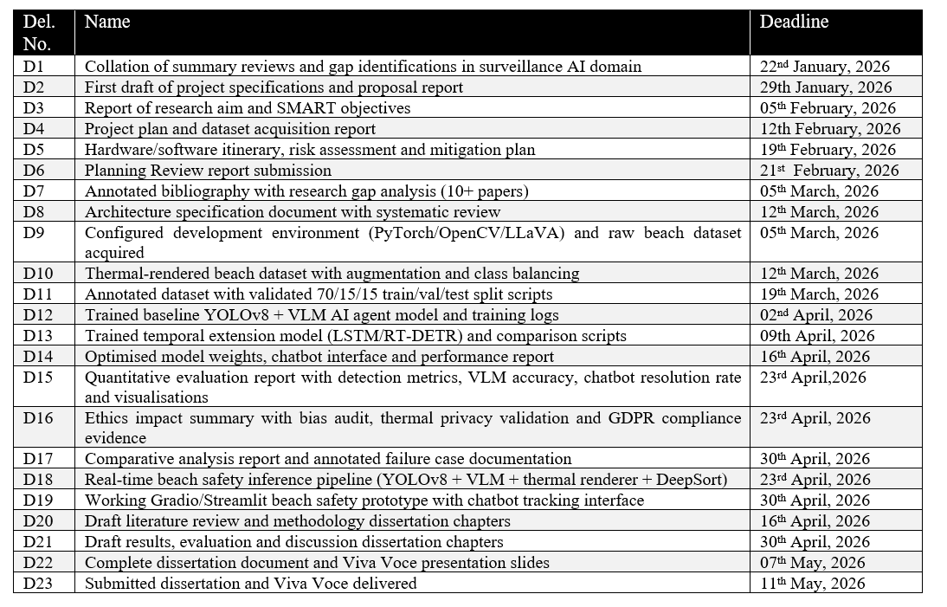

Table 3: Milestones

The six milestones below are key checkpoints in the project. For each, I will specify the evidence to confirm its completion.
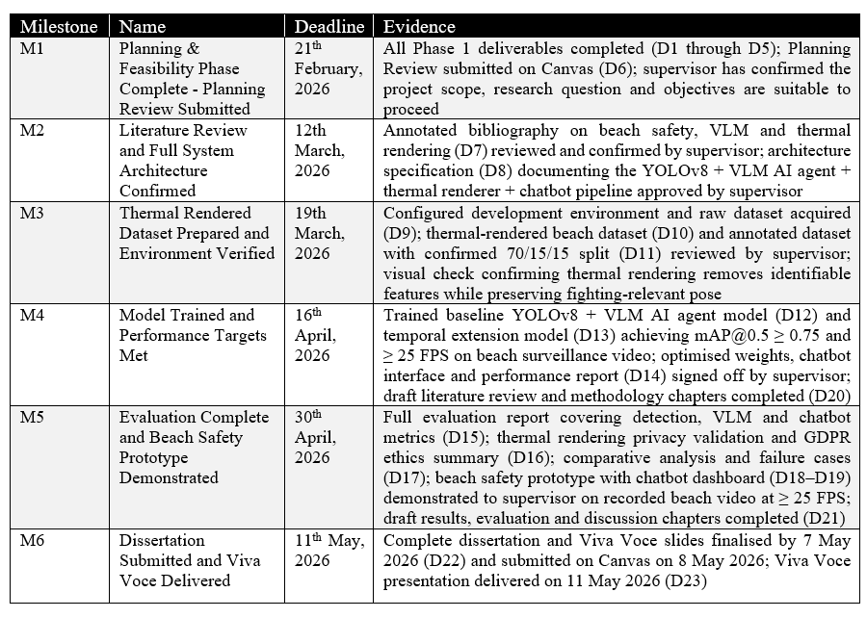

Table 4: Outline Schedule / Gantt chart

This Gantt chart describes the currently active phases and subtasks and contains deliverable codes for each cell. There are milestone markers that indicate when each phase is expected to be finalized. The week numbers start at 1 (the week of 16 January) and go through to the week of the Viva (May).

 | January 2026 |  |  | February 2026 |  |  |  |  | March 2026 |  |  |  |  |  | April 2026 |  |  |  |  | May 2026
 | 1 | 2 | 3 |  | 4 | 5 | 6 | 7 |  | 8 | 9 | 10 | 11 | 12 |  | 13 | 14 | 15 | 16 |  | 17 | 18
Major Task 1 | 1.0 Planning and Feasibility Analysis Phase (M1)
Sub Task 1 | D1 | D1
Sub Task 2 |  | D2 | D2
Sub Task 3 |  |  | D3 |  | D3
Sub Task 4 |  |  |  |  | D4 | D4
Sub Task 5 |  |  |  |  |  | D5 | D5
Sub Task 6 |  |  |  |  |  |  | D6/M1
Major Task 2 | 2.0 Literature Review & Research (M2)
Sub Task 1 |  |  |  |  |  |  | D7 | D7 |  | D7
Sub Task 2 |  |  |  |  |  |  |  |  |  | D8 | D8/M2
Major Task 3 | 3.0 Data Acquisition & Preprocessing (M3)
Sub Task 1 |  |  |  |  |  |  | D9 | D9 |  | D9
Sub Task 2 |  |  |  |  |  |  |  | D10 |  | D10
Sub Task 3 |  |  |  |  |  |  |  |  |  |  | D11 | D11/M3
Major Task 4 | 4.0 Model Development & Training (M4)
Sub Task 1 |  |  |  |  |  |  |  |  |  |  |  | D12 | D12 | D12
Sub Task 2 |  |  |  |  |  |  |  |  |  |  |  |  |  | D13 |  | D13
Sub Task 3 |  |  |  |  |  |  |  |  |  |  |  |  |  |  |  | D14 | D14/M4
Major Task 5 | 5.0 Evaluation & Ethical Review (M5)
Sub Task 1 |  |  |  |  |  |  |  |  |  |  |  |  |  |  |  |  | D15 | D15
Sub Task 2 |  |  |  |  |  |  |  |  |  |  |  |  |  |  |  |  | D16 | D16
Sub Task 3 |  |  |  |  |  |  |  |  |  |  |  |  |  |  |  |  |  | D17 | D17/M5
Major Task 6 | 6.0 Prototype Development (M5)
Sub Task 1 |  |  |  |  |  |  |  |  |  |  |  |  |  |  |  |  | D18 | D18
Sub Task 2 |  |  |  |  |  |  |  |  |  |  |  |  |  |  |  |  |  | D19 | D19/M5
Major Task 7 | 7.0 Dissertation Writing & Submission (M6)
Sub Task 1 |  |  |  |  |  |  |  |  |  |  |  | D20 | D20 | D20 |  | D20 | D20
Sub Task 2 |  |  |  |  |  |  |  |  |  |  |  |  |  |  |  |  | D21 | D21 | D21
Sub Task 3 |  |  |  |  |  |  |  |  |  |  |  |  |  |  |  |  |  |  | D22 |  | D22
Sub Task 4 |  |  |  |  |  |  |  |  |  |  |  |  |  |  |  |  |  |  |  |  | D23 | D23/M6

Evaluation Plan

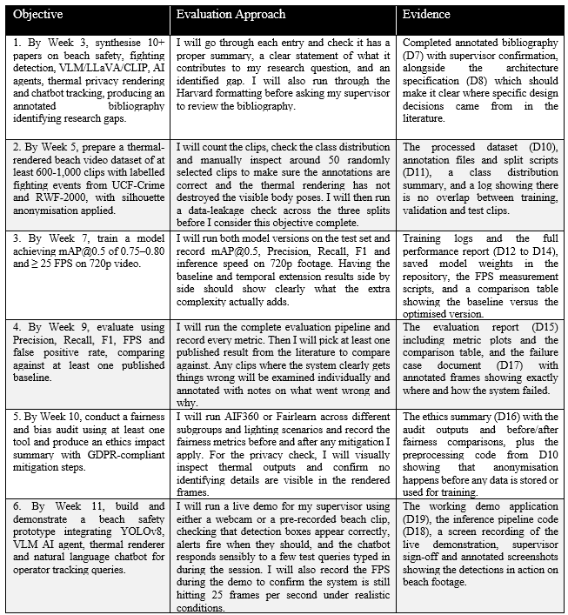

Social, Ethical, Legal and Professional issues

Social, Ethical, Legal and Professional Issues Table

Social issues | The use of technology to automate the detection of fighting on beaches improves public safety but raises issues about the dignity of individuals who will be captured in swimwear. To resolve these concerns, the warm shape thermal pipeline anonymizes the outline of a person's body in raw footage to remove any identifiable images of the individual from the footage. Additionally, the chatbot will only allow authorized operators (who are dealing with active incidents) to track individuals' movements in the automated system, which will make the automated system a targeted tool for public safety and not a general surveillance tool.
Ethical issues | The most serious ethical violation is VLM making hallucinations; i.e. the model creates a false description with high confidence that could be the basis for taking action that should not be taken. All VLM output will be audited for reliability and the percentage of VLM hallucinations reported to the public. Thermal abstractions guarantee that an unclothed beach model is not able to be identified after an intervention. All VLM operators will be appropriately validated to ensure there is a lower chance of misuse of the VLM. Sources of training bias (UCF-Crime as a predominantly indoor example) will be thoroughly tested and documented so as not to rely upon hidden or silent adjustments to remove bias, thus ensuring transparency when reporting the limitations of the system. Additionally, I want to meet with the VLM to provide feedback on my use of the system and allow for future potential collaboration.
Professional issues | The project is in alignment with the ACM Code of Ethics, which includes, for example, Principle 1.6 - "respect for privacy" and Principle 1.2 - "avoid harm to others." Using thermal abstraction implements privacy by design principles. The integrity of professionals is ensured through the use of Git version control systems, properly citing work performed by others and through supervisor review (frequently). A human-in-the-loop design allows for operational decisions to be made by authorized personnel. Additionally, the transparent reporting of false positives and the limitations of VLM continues to promote the expectation of professionalism and professional standards throughout the entire process.
Legal Issues | The system is compliant with UK GDPR and EU AI Act. By thermal rendering, the requirement of minimisation of data under Article 5(1)(c) of the GDPR is fulfilled through the conversion of raw video to an anonymised outline prior to any storage and processing. The use of tracking/chatbot meets the purpose limitation requirement of Article 5(1)(b) (purpose limitation) as only those who have been authorised to use such data are able to access that data during an active incident. Data will be saved for the duration of the project on secure servers approved by the University, while open source tools are used in compliance with each respective agreement.

Ethics Approval

Prior to commencing any data processing activities, I will apply for and obtain an ethics approval via the University of Sunderland Research Ethics Committee via their online portal. Because this research project will use only publicly available datasets and does not involve any participant recruitment or the collection of any new individual personal data, I expect that the application process will be straightforward. However, I will not commence processing any datasets until I receive a formal response from the Research Ethics Committee. Any supporting documentation received will be appended in the dissertation.

References

Evany Anne, M. and Sivakumaran, N. (2025) 'An intelligent crime surveillance video system for real-time applications', Procedia Computer Science, 260, pp. 635–644. https://doi.org/10.1016/j.procs.2025.03.242 [Accessed: 12 January 2026].
Fatima, K. and Ahmed, M. R. (2025) 'Real-time crowd crime and violence detection using deep learning-based face recognition and object detection', International Journal of Scientific Research in Engineering & Technology, 5(4), pp. 20–23. https://doi.org/10.59256/ijsreat.20250504004 [Accessed: 11 January 2026].
Jocher, G., Chaurasia, A. and Qiu, J. (2023) Ultralytics YOLOv8 [Software]. Version 8.0.0. Available at: https://github.com/ultralytics/ultralytics [Accessed: 15 January 2026].
Ojha, R. R., Chawdary, H. and Saraswat, S. (2025) 'Enhancing public safety: real-time violence detection and notification system', Procedia Computer Science, 258, pp. 2988–2995. https://doi.org/10.1016/j.procs.2025.04.558 [Accessed: 12 January 2026].
Qi, B., Wu, B. and Sun, B. (2025) 'Automated violence monitoring system for real-time fistfight detection using deep learning-based temporal action localisation', Scientific Reports, 15(1), article 29497. https://doi.org/10.1038/s41598-025-12531-4 [Accessed: 10 January 2026].
Redmon, J. and Farhadi, A. (2018) 'YOLOv3: An incremental improvement', arXiv preprint arXiv:1804.02767. Available at: https://arxiv.org/abs/1804.02767 [Accessed: 14 January 2026].
Solak, S., Cetin, B. and Ucar, M. H. B. (2025) 'Real-time theft detection in urban surveillance: a comparative analysis of YOLO-based approach', Journal of Engineering Research. https://doi.org/10.1016/j.jer.2025.11.009 [Accessed: 13 January 2026].
Sultani, W., Chen, C. and Shah, M. (2018) 'Real-world anomaly detection in surveillance videos', Proceedings of the IEEE Conference on Computer Vision and Pattern Recognition (CVPR), pp. 6479–6488. https://doi.org/10.1109/CVPR.2018.00678 [Accessed: 10 January 2026].
Tran, D., Bourdev, L., Fergus, R., Torresani, L. and Paluri, M. (2015) 'Learning spatiotemporal features with 3D convolutional networks', Proceedings of the IEEE International Conference on Computer Vision (ICCV), pp. 4489–4497. https://doi.org/10.1109/ICCV.2015.510 [Accessed: 15 January 2026].
Verma, A. (2025) 'Real-time violence detection in surveillance streams', SSRN. Available at: https://papers.ssrn.com/sol3/papers.cfm?abstract_id=5326645 [Accessed: 11 January 2026].

